**227/07/2021 Notes (Demonstration Modals)**



**Notes**

Demonstration modal are modals that will demonstrate how to perform actions in the Console (Cloud Winterstore).

The type of modals we want to show are inspired by [Lucid Charts](https://www.googleadservices.com/pagead/aclk?sa=L&ai=DChcSEwjCtaXyvIPyAhXhgFAGHYViAzcYABACGgJkZw&ae=2&ohost=www.google.com&cid=CAESQeD2dtvFBebFPChYQE0XTjGmLcnxIY_PtrMgnabCAdK08wHBvOm1fyx2PdvmjWN9HXQTaHvdKJP4CHkAZ5Ps_nN5&sig=AOD64_2FqE89tdUDaqxYXTath0Bj4NnwXw&q&adurl&ved=2ahUKEwi84p7yvIPyAhVUVsAKHWm6AXoQ0Qx6BAgEEAE), preview below

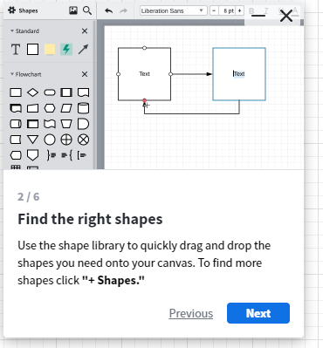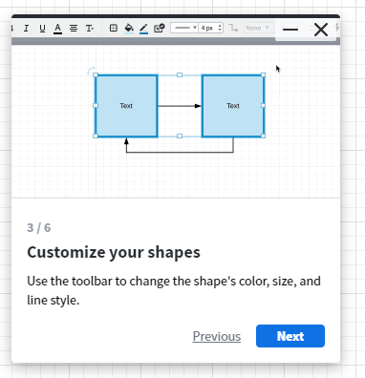

However, we want to do this over multiple pages, these pages which include

**Admin Panel Projects**: Show how to create, edit and load a project

**File Browser Page:**

* Show how to create a new folder**.**
* Show how to upload a file.
* Show how to download a file.
* Show upload and download modal.
* Show how to open access control modal and add access to a file.
* Show how to reload index.

**Client Accounts Page:**

* Should first redirect to the integrations page- where they will be shown how to create an integration, and then comes back to show how to create an account.
* How to barn an account.
* How to un-barn an account
* How to edit a client.

**Admin Clients page:**

Add someone else to a project.

Things to note:

* We do not want to show the demonstrations on a mobile device.
* We want a reusable component to make development quicker, and less code.

Some decisions to make:

* How will we determine if it’s a clients first time on Console?

**Model Description/ Solution**

* We should check if the device has a screen size less than n before showing a modal
* Components since each frame is the same, should allow us to add a list [] of type **DemonstrationObject** to it and it should navigate that list.
* A demonstration object should have the following fields

**String** VideoURL

**String** Description

**String** Body

* The modal should show when the first video has loaded and then starts caching the next videos

